PC Builder Web Application

Kevin Song, SiYuan He, Xu Zhang, HaiMiao Yu, Chhanna Gaha, SiChao Liu

*CS691*

*Seidenberg School of Computer Science and Information Systems*

*Pace University, New York, NY, USA*

***Abstract* —With the rapid development of technology, computers have already become an essential part of our life, especially for students as well as people who are engaged in the information technology field. Since nowadays people rely much on computers, a suitable computer can significantly improve the efficiency of their daily jobs. Although it is easy for us to purchase any computer or parts online, choosing a hardware configuration of a computer can still make us very indecisive. A computer without an appropriate configuration will potentially cost more to upgrade later. Therefore, the purpose of our project is to help people purchase the hardware of a computer which can highly meet their needs. Also, our application will sync our users with the most recent technology not only because of the dynamic change of user needs but also the rapid iteration of technology.**

***Keywords***—**PC hardware**, **web application, PC builder**

1. Introduction

This web application provides specialized hardware guidance for different groups of customers such as students, engineers and so on. Today people benefit from web services a lot with its advantage on reducing cost and saving time. We are going to apply the Responsive Web design to make the user feel comfortable with the browsing experience when they visit our website.

In our application, we will use React and MongoDb as a database to support the frontend application. Here are some basic processes for the new user when they visit our website the first time. First, when they visit our website, they will be directed to the main sale page with sign in function. Then they can have a quick registration. Our website will ask users to enter their name and email address. As long as they finish this simple registration. The website will add the user to database and remember his selection. Once user registered. The users can login onto their account by their email address and password next time.

Moreover, as the website manager, an admin can upload a product in a few clicks and give a product the right description. If the user is a student who is majoring in computer science but does not having strong pc hardware knowledge, we will provide them with hardware suitable for programming. If the user is a gamer that needs strong performance, our website will offer powerful builds that match the buyer’s requirement.

Finally, we have the rating system for users to share their experience of purchasing the hardware so the other user will see the popularity of the system. Our website will also have a section which shares technical articles to educate users with knowledge regarding PC hardware.

1. Literature Survey

As we all know, there are plenty of manufactures providing customized hardware products to meet the needs of the customers. However even with so many modernized online shopping platforms, it is still not straightforward for users to find a hardware product with satisfaction.

Based on our survey, there are some common pain points people may have for their computers. Some people complained of the issue of the computer not being responsive once they use it to watch their favorite TV series. Other people are glooming about hardware overheating and the concern for safety. And another quite common problem people have is the tradeoff between limited budget and performance.

When we did customer research, we met with two users who can represent a significant number of users. Nancy, a Computer Science student, found that there are so many laptop brands with similar hardware. As a result, she had a hard time making a purchase decision.

Han, an Engineer who is an experienced IT professional, still struggles to find right PC hardware which can match his field of work. He found that many online pc seller websites are not very responsive which made the purchasing process difficult.

With our survey and research, we can see that finding the right hardware configuration with the best possible cooling option is difficult, while the website being quick and easy to use is another obstacle we need to overcome. This is also our solution’s market fit. Our solution tries to provide a one-stop experience to facilitate and guide customers to find hardware to meet their technical and financial requirement in a timely fashion.

1. Project Requirements

Software Requirements:-​

Mozilla Firefox 4.0 or above, Microsoft Edge, Google Chrome.

Hardware Requirements:-

● We need the version of the processor after Intel Core 2 Duo.

● The operating System should be capable of running the browsers.

Functional Requirements:-

● We should enable user to login and register easily.

● We should differentiate user and admin user.

● We should redirect logged-in users to the homepage.

● We should keep the user logged until user logout manually.

● Users should be able to add desired item to cart

* Cart should remember item

Refresh screen will not discard item

● Users can upload, edit and delete their user profile.

● Users can purchase product and add shipping.

● The administrators can manage user information and check any order placed by user.

Technical Requirements:

* This is a web application which should support users browse from PC end and mobile end.
* This web app will be implement using react, node.js, redux, postman.
* Other technologies used would be HTML, CSS, and Mongo dB Compass.

Usability Requirements:

● The web application will be functional in all the major web browsers.

● The web application will have a simple user interface

1. Team Roles

The roles in Scrum are quite different from the traditional software methods. Clearly defined roles and expectations help individuals perform their tasks efficiently. In Scrum, there are three roles: Product Owner, Development Team, and Scrum Master.

When our scrum team takes responsibility for projects and products, we produce great results. Our team collaborates and takes ownership of quality and project performance through the following practices: Having the development team, the product owner, and the scrum master work closely together on a daily basis.

* *Product Owner*– *SiChao Liu*
  + Owns the [Product backlog](https://www.visual-paradigm.com/scrum/what-is-product-backlog-in-scrum/) and writes user stories and [acceptance criteria](https://www.visual-paradigm.com/scrum/definition-of-done-vs-acceptance-criteria/).
  + Ensures the accuracy of the code and debugging.
  + Enables close cooperation across all roles and functions.
* *Scrum Master* – *Kevin Song*
  + Holds every team meeting.
  + Maintains project’s GitHub and wiki.
  + Reviewed documents for grammar accuracy and assisted with debugging.
* *Team member* – *Chhanna Gaha*
  + Maintains project’s Github and wiki.
  + Documented test cases and assisted with the design of database.
  + Helped product owner properly prioritize tasks.
* *Team member* – Xu Zhang
  + Authored technical documentation.
  + Researched and Developed Personas in Product Design.
  + Managed burn down charts and forecasted project timeline.
* *Team member* – *HaoMiao Yu*
  + Records the feedbacks from classes and put forward suggestions for improvements.
  + Authored technical documentation.
  + Served as the moderator for a retrospective session after a sprint.
* *Team member*– *SiYuan He*
  + Made and combined every video for sprint presentations.
  + Designed PowerPoint for sprint presentations.
  + Designed product home page layout and assisted with back-end code.

1. System Diagrams

User-Case Diagram

ADMIN-



USER-



1. Database

**UserModel**

Description: To store the details of user and admin

|  |  |  |
| --- | --- | --- |
| **Fields** | **Data Types** | **required** |
| id |  | true |
| User_name | String | true |
| Email | String | true |
| Password | String | true |
| IsAdmin | Boolean | Default:false |

**ProductModel**

Description: To store the details of user and admin

|  |  |  |
| --- | --- | --- |
| **Fields** | **Data Types** | **required** |
| price | Number | true |
| name | String | unique |
| image | String | true |
| brand | string | true |
| category | String | true |
| description | String | true |
| countInStock | Number | true |
| numReviews | Number | true |

**OrderModel**

Description: order Items

|  |  |  |
| --- | --- | --- |
| **Fields** | **Data Types** | **required** |
| name | String | true |
| qty | Number | true |
| image | String | true |
| price | Number | true |
| product | It is getting type from database Object Id | true |

Description: To store shipping Address

|  |  |  |
| --- | --- | --- |
| **Fields** | **Data Types** | **required** |
| fullName | String | true |
| address | String | true |
| city | String | true |
| postalCode | String | true |
| country | String | true |

Description: To store item status

|  |  |  |
| --- | --- | --- |
| **Fields** | **Data Types** | **required** |
| itemsPrice | Number | true |
| totalPrice | Number | true |
| user | It is getting type from Object Id | true |
| isPaid |  | void |
| PaidAt |  | void |

1. Data Modeling

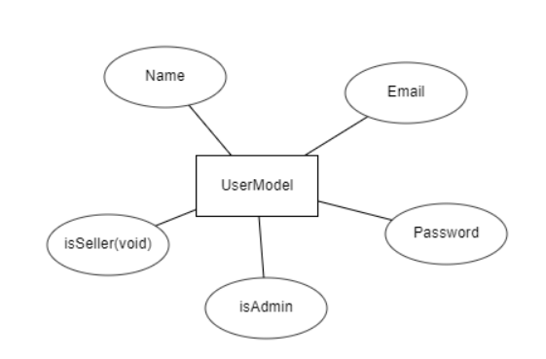

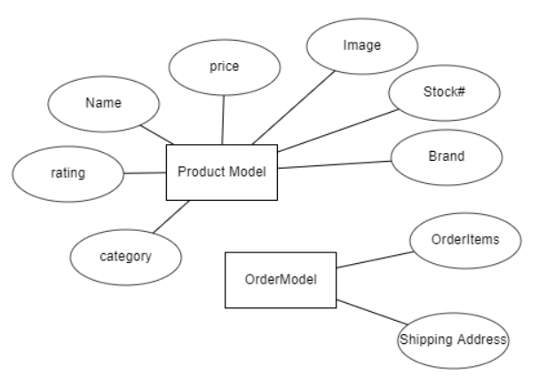

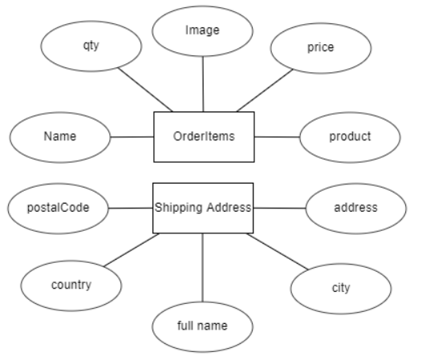

1. ADVANTAGES
2. React runs in browser, the web app is going to react fast.
3. React is a component driven framework, many components can be reuse in the future implementation.
4. Redux is added to manage stat, many errors can be detected, also post man can easily test API for backend.
5. Future Scope

The website still has potential to grow. We haven’t completed these functions; However, we do have these plans for its future.

1. Admin can chat with user
2. A Search engine
3. User will have option to customize their pc.
4. A forum will be created as a community for our users.
5. User can become seller
6. A better-looking website
7. Product results

A functional registration, login/logout, production listing, and shopping cart have all been completed during Sprints 1 through 4 of app development. As of Sprint 5, development of the user profile was begun, with the user profile being designed and displayed. However, a database error was encountered during the implementation of the ability to update a user’s profile, which has subsequently been resolved in Sprint 6. Sprint 6 also saw the completion of the administrator product management view, which allows admins to add new product listings and display all currently ordered items. Again, a similar database error prevented the implementation of a function allowing admins to update a currently listed product.

In Sprint 7, the database error was resolved, while work on adding the ability to upload and edit a product’s image began. Adding the feature of an admin user management page and its functions was also carried out, with the List and Delete User functions being completed this sprint.

In the final Sprint 8 the team completed the remaining Edit User function for the user management page but had to forgo adding the ability to upload and edit images for added products due to time constraints. Subsequently, the development of a Seller page had to be skipped. Finally, due to several false actions inside the important .gitignore file, and the Heroku website rejecting the mongoDB link, deployment of the website was unfortunately unsuccessful at the end of Sprint 8.

1. Conclusions

The importance of computers remains and integral part of modern society and it is imperative that users of various backgrounds have a simple and intuitive platform in which to not only buy a computer, but to have it customized to his or her needs and budget. In this paper, we introduced the PC Builder web application developed in React and implementing Google Firebase, allowing for a modern and smooth user experience.

The aim of this work is to create a simple yet powerful website that conglomerates the latest computer parts on the market into one place. We want to eliminate the intimidating aspect of buying a customized PC by incorporating an easy-to-use interface where casual buyers can create a computer that balances both their personal needs and budget. Enthusiasts can find more detailed options allowing for advanced customization and part searches. Finally, with the planned addition of the rating system, forum section, and tech news pages in the future, we aim to make the web app an interactive and social platform as well.

Reference

1. O. Molly, “Common PC Hardware Problems” *Remosoftware*, 15-Jun-2020. [Online]. Available:

<https://www.remosoftware.com/info/common-pc-hard-ware-problems>. [Accessed: 04-Oct-2020].

1. H. John, “Fixes for Six Common Laptop Problems” *Remosoftware*, 08-Sept-2020. [Online]. Available:

https://www.remosoftware.com/info/fixes-six-common-laptop-problems. [Accessed: 04-Oct-2020].

1. “Computer hardware,” *Wikipedia*. [Online]. Available:

https://en.wikipedia.org/wiki/Computer_hardware.[Accessed: 05-Oct-2020].

1. “What is Computer Hardware?” *Crucial*. [Online]. Available: https://www.crucial.com/articles/pc-builders/what-is-computer-hardware[.](https://firebase.google.com/docs/auth) [Accessed: 05-Oct-2020].
2. F. Tim, “Everything You Need to Know About Computer Hardware” *Lifewire*, 11-Sept-2020. [Online]. Available:

https://www.lifewire.com/computer-hardware-2625895. [Accessed: 05-Oct-2020].

1. “Computer Hardware Types” *Wikiversity*. [Online]. Available:

https://en.wikiversity.org/wiki/Computer_Hardware_Types. [Accessed: 06-Oct-2020].